PROBLEM 1

PART 1

STARTING TO MAKE THE CLUSTER

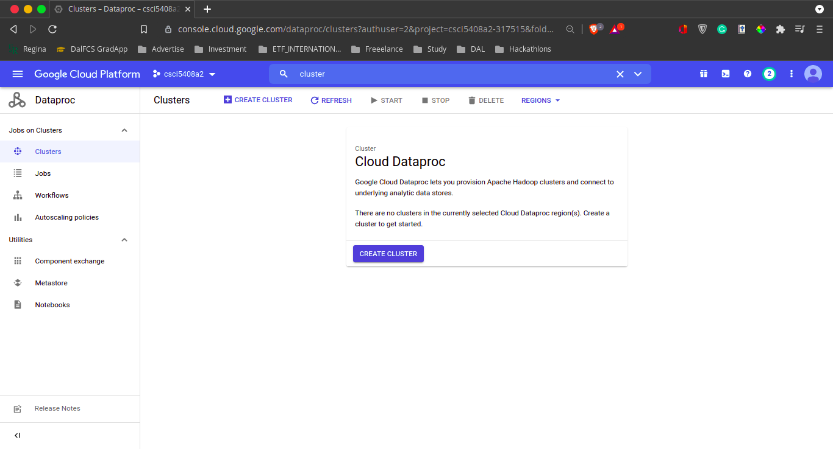

NAMING THE CLUSTER AND SELECTING REGION

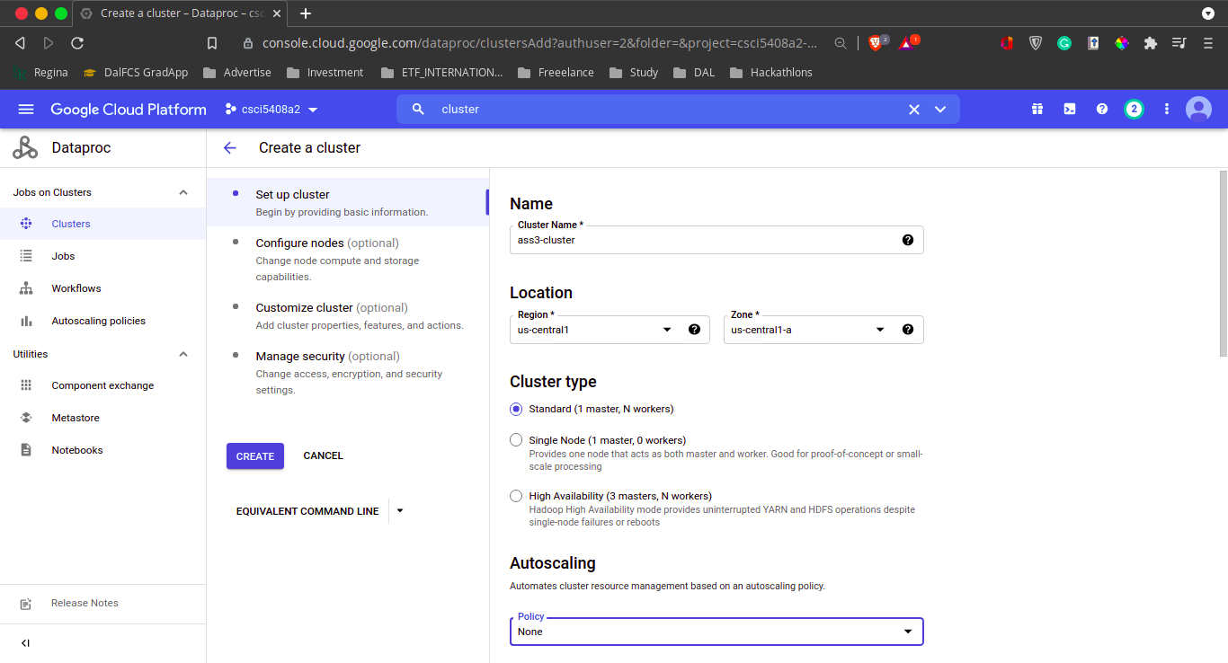

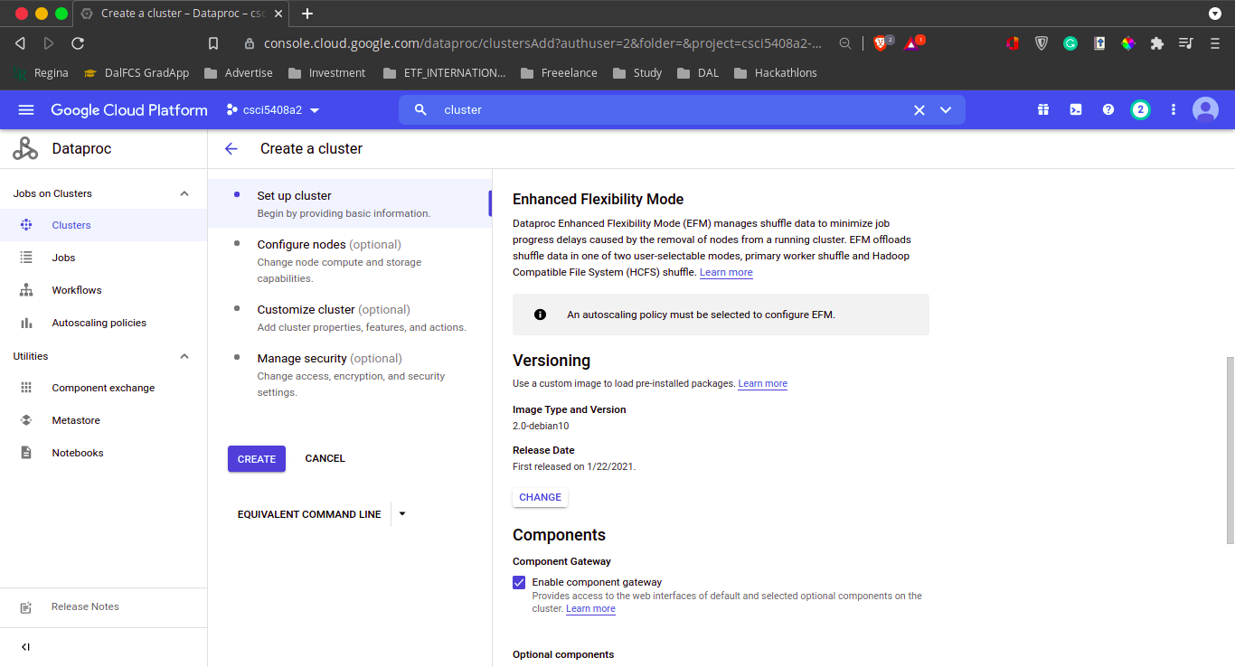

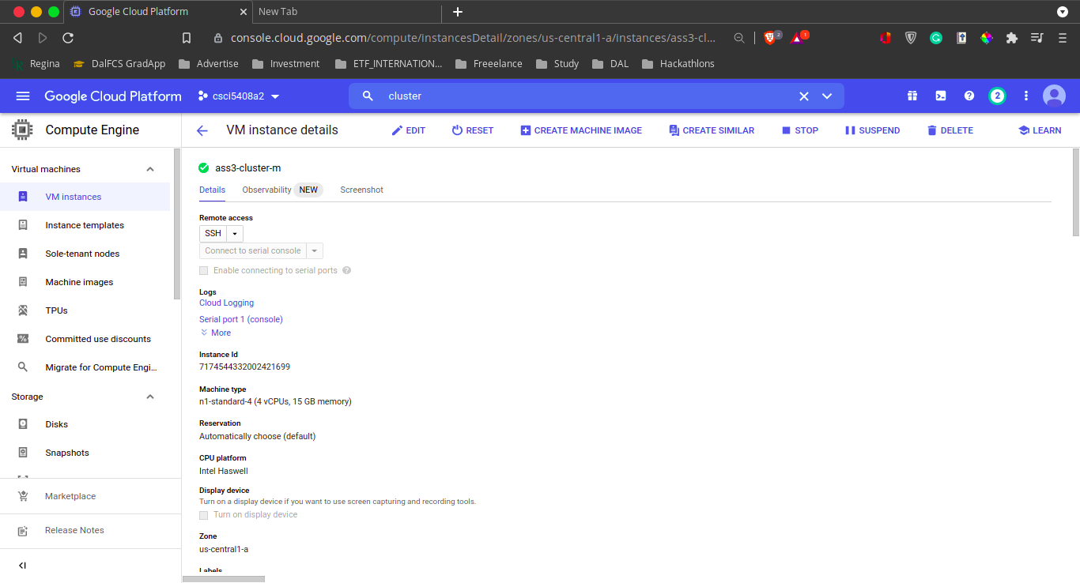

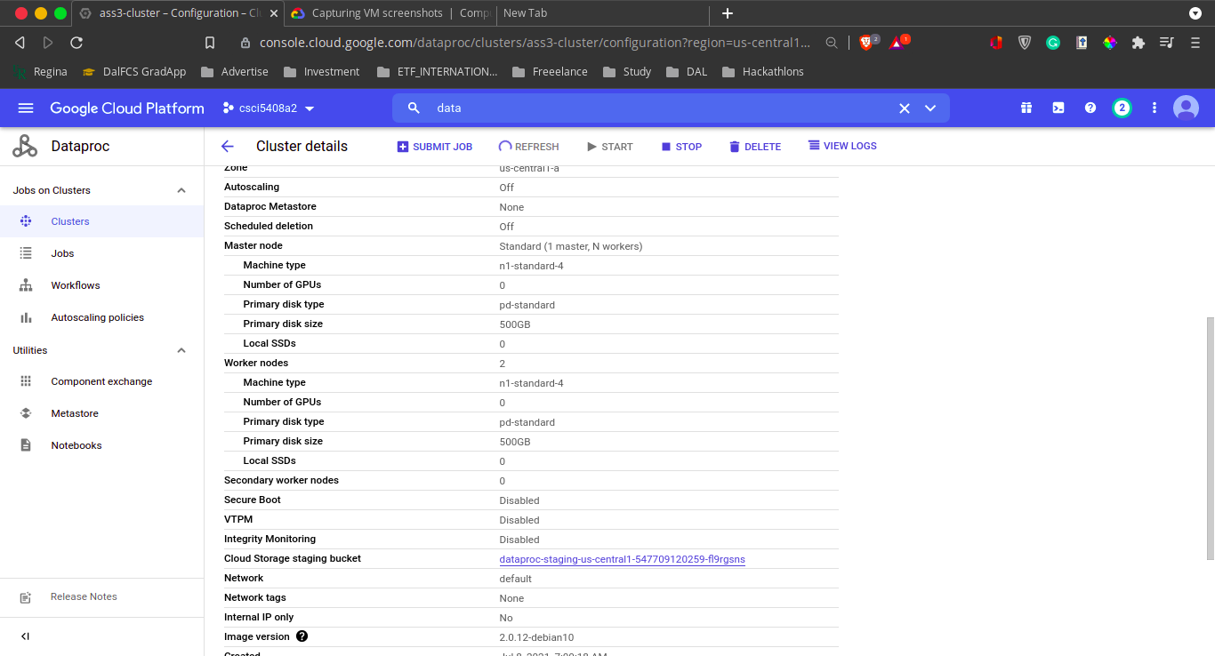

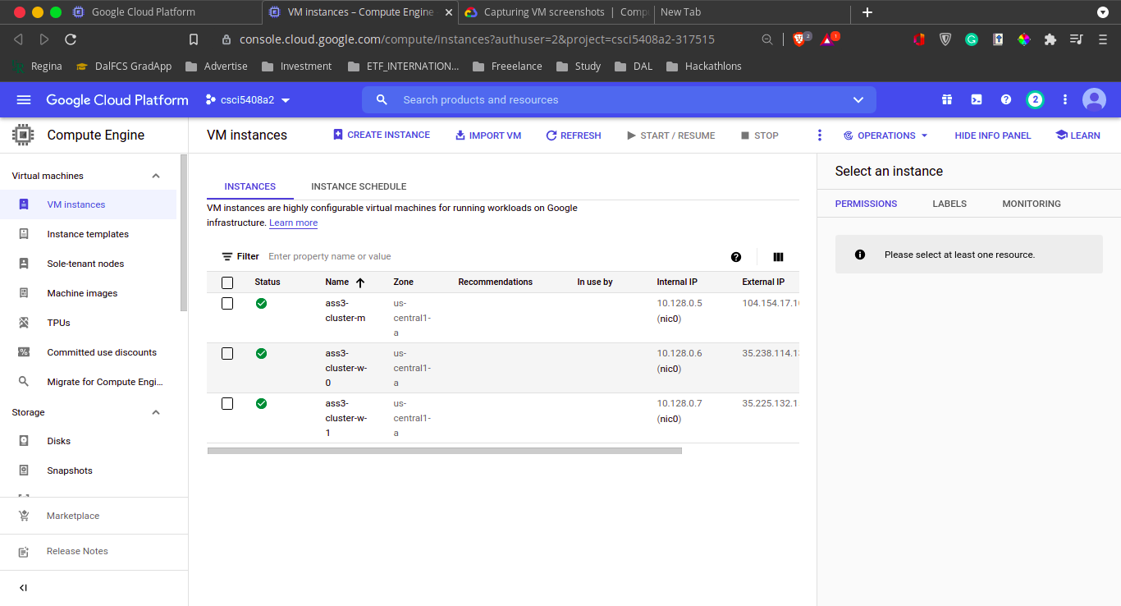

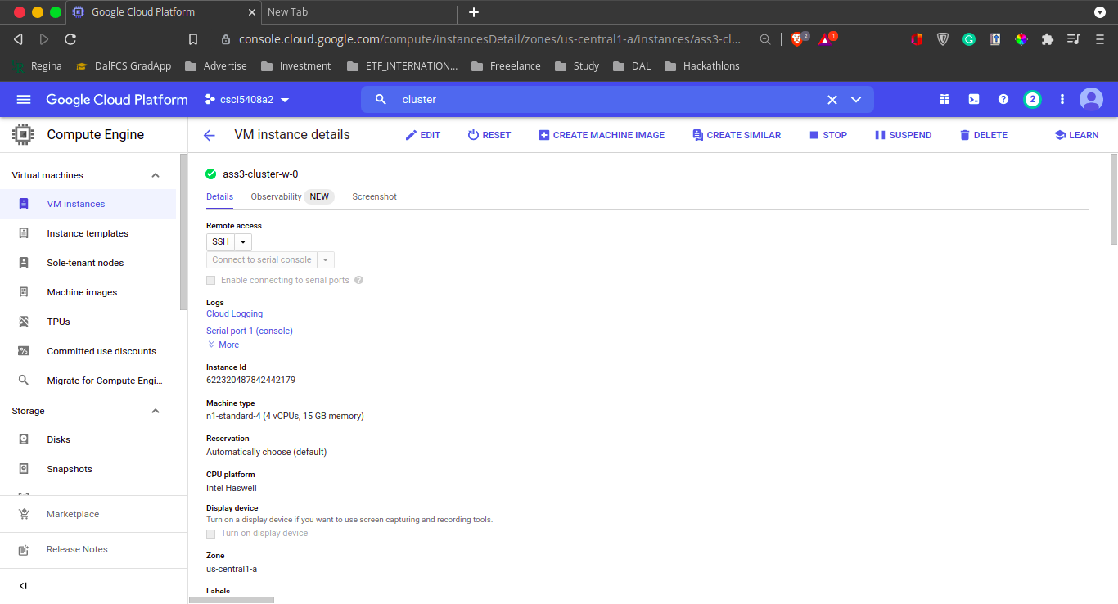

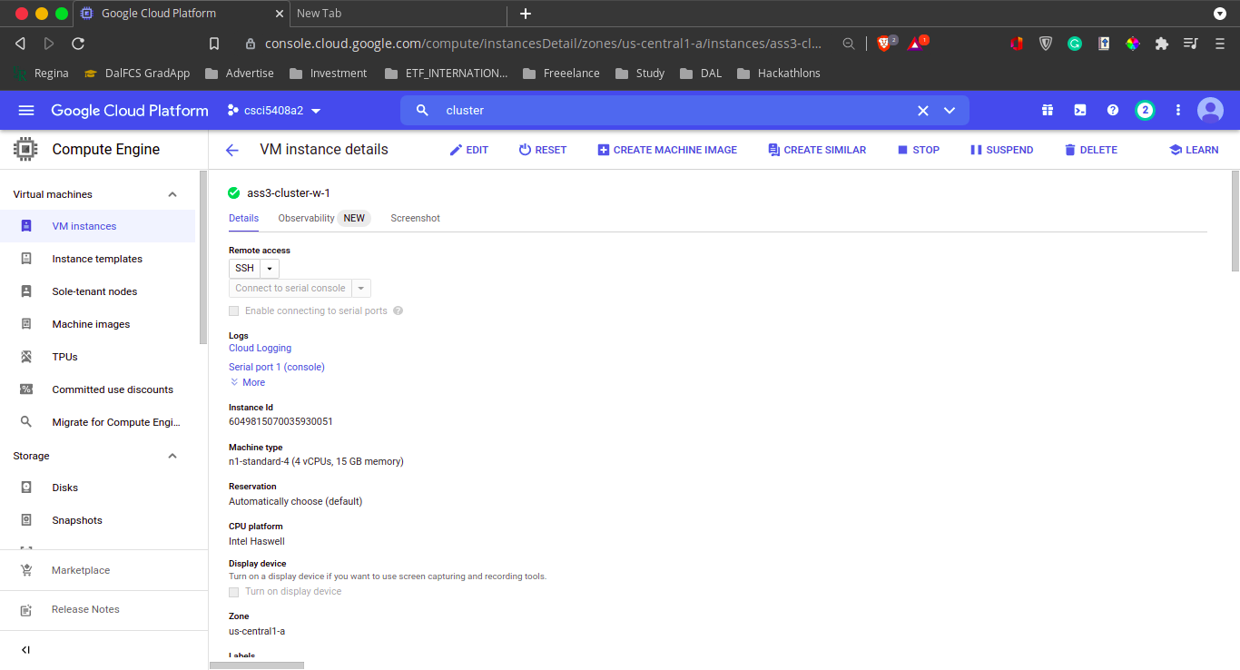

As shown in the images the Apache spark cluster is created on GCP. Here I just deployed the Cloud prop cluster which will allow us to create multiple VM’s to handle data. Continuing with that we need to have three vm’s which will work with the Hadoop framework. Now here we are having three vm's, ass3-cluster-m which is master VM where as another 2 VM which are ass3-cluster-w-0 and ass3-cluster-w-1.

I started the Master Node and checked it by opening the URL on the browser. It was running fine. To check the proper installation of Apache spark was properly conducted.

After that with SSH I tried to work with the VM’s and moved ahead with no issues. Hence I could figure that it is working completely fine.